My name is John Loonsk and I am here on behalf of the American Medical Informatics Association. We would like to thank the NCVHS for this opportunity to testify.

On September 11th of 2002 on the one year anniversary of the World Trade Center attacks I flew into Washington, DC to also testify before NCVHS. I was testifying on that date because of the anthrax attacks that had also occurred the year before and I testified about the critical importance of establishing electronic case reporting between clinical care and public health.

Now over ten years and fifteen billion HITECH EHR incentive dollars later, basic case reporting does not seem to be on a path for inclusion in even the third stage of Meaningful Use. Surveillance is a, if not the, core capability for public health and it is central to population health registries in clinical care as well. The lack of general case reporting is the biggest issue with the current state of public health standards. It may be a long time before we have another incentive opportunity like HITECH. It is a failure of the public’s trust and resources to not have this basic capability in what is slated to be the last Meaningful Use incentive stage and may indeed be the last opportunity to really guide the public’s interests in this large investment.

We have a unique opportunity to establish a general case reporting platform and general “foot hold” in Stage III. This “platform” will allow for extension into many areas of public and population health needs and I will focus my comments on that goal. There is still time to put case reporting into Stage III, the majority of the components of the work have been engaged. We just need to think holistically about the broad surveillance needs, learn some of the lessons from the past, and reorient the existing components to playing a role in that whole.

Certainly standards for case reporting are hard. Among other things, there is a many to many integration problem. The many categorical disease programs times the many jurisdictions times the many EHRs makes this inter-organizational integration very hard. Compounding that complexity are dynamic needs during emergencies and the challenges of meeting both management and reporting.

If making reporting electronic is a complex challenge by itself, electronic reporting is also expected to accomplish much more in terms of:

* Timeliness - New expectations have been set by other countries where clinical care events are immediately analyzed by public health authorities.
* Yield - The historically low rates of the legally mandated reporting of disease threats must be addressed in electronic reporting.
* Completeness – Often when paper reports are submitted, not all data a present.
* Coordination – Jurisdictional and categorical program variations need to be as invisible as possible to the many EHR vendors and clinical care sites that need to execute reporting. They want as close to a singular and minimally burdensome process representing all of public health, as they can get.
* Management and reporting – As seemingly basic as this is, case reporting serves the dual functions of managing cases to link lab results, track contacts etc., and the more passive needs of reporting and tracking of trends.
* Dynamic flexibility – As important as monitoring disease trends over time is, almost all emergencies represent breaks from the norm. New data on symptoms, environmental factors, or disease specifics are almost always needed in a public health emergency to meet changing case definitions. This may be the most important aspect of surveillance.

There has been a lot of groundbreaking work done in Electronic Laboratory Reporting, in Immunization Information Systems, in dynamic information capture from EHRs and in the National Electronic Telecommunications System for Surveillance (NETSS) and the National Electronic Disease Surveillance (NEDSS) efforts. One lesson is the importance of a “core” case report with extensions built on top of it. From this and other work there is also a clear pattern for the several transactions and hence standards that are needed to make basic case reporting work. This is not a problem that can be addressed by just doing the paper reporting process electronically. Using paper, reporting is essentially a single transaction where a health care provider decides that a case is reportable, fills out a form, and sends it to their health department.

The good news is that these transactions that are critical for infectious disease case reporting are also the ones that are important for defining population health and chronic disease surveillance as well. When more attention is focused on non-EHR, clinical care applications, these transactions will be key to defining population health and chronic disease systems that can support case management, prevention and more.

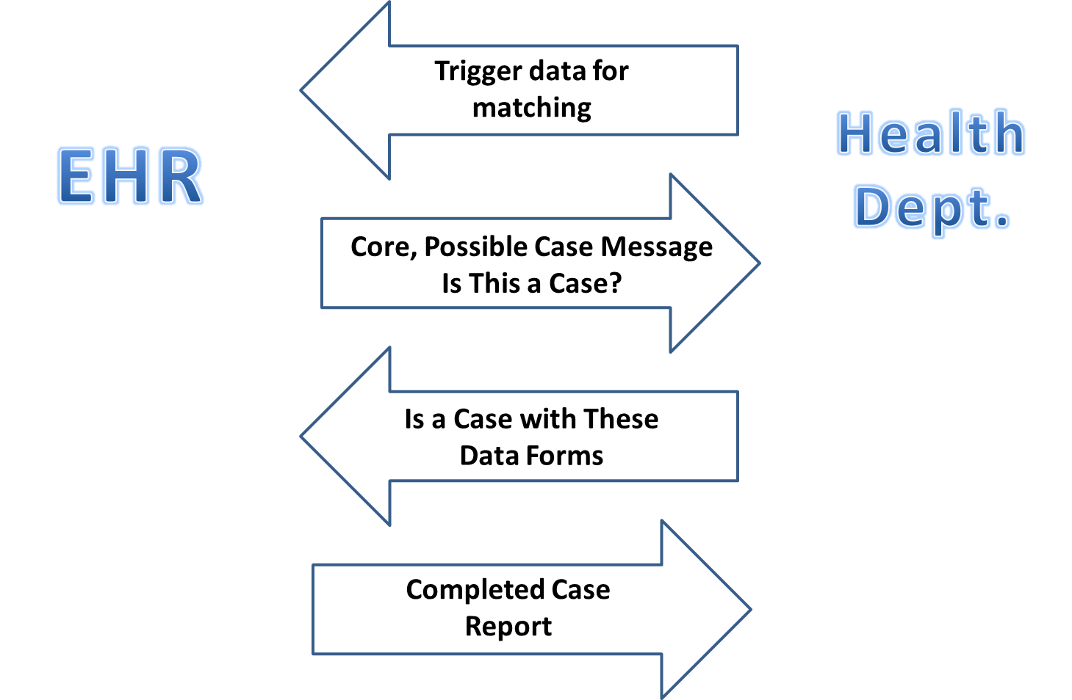

Unlike paper reporting, electronic reporting actually needs multiple transactions and standards to support these transactions as a whole;

1. “Trigger codes” that identify diseases and conditions of interest to public health need to be reliably available to EHRs and their implementers. As in ELR, these codes are used in clinical care to match against EHR data (such as problem lists) so as to automatically initiate the second transaction,
2. When a code of interest is matched, it triggers the EHR to automatically send a “core, possible-case report message.” This initial message serves two purposes. As an automatic message it can be used immediately for syndromic / biosurveillance purposes. But the message is also acting to ask the health department “Is this be a reportable case?” and “How do I report it?” Because this preliminary case message may not yet meet legal requirements for named case reporting, it should be pseudonymized,
3. The health department then responds with a web link and/or electronic form for the provider. Essentially the response is saying “This is a reportable case if these data / criteria are provided.” The provider or their staff is guided to complete the remaining data for the full case report. Because this supplemental information is dynamically presented, public health has the ability to ask for routine reporting information or, importantly, new critical data that may be needed as part of a public health response / emergency,
4. The full case report is then completed and submitted electronically. The provider is supported by pre-population of the form from the possible report and, over time, with more of the available EHR data can be auto-populated. Public health is advantaged because they already have a preliminary indication that there may be a case and know the provider with whom to investigate. These supplemental data are also the ones that are lease likely to be natively in an EHR, vary by disease / syndrome, or vary jurisdictionally.

All of this can be done using existing initiatives including PHRI, SDC, Health eDecisions, Data Access Framework, PHIN VADS and RCKMS. But what specifically is done in these initiatives needs to be driven by the public health needs of this combined transaction set.

Needs

1. National public health leadership should insist that an automatically initiated “core, possible-case report message” is included in Stage III of Meaningful Use.
2. Public health “trigger codes” for diseases and symptoms of interest to public health should be identified, managed and made accessible to all EHR vendors and implementers.
3. The web services and forms should be made available so that “core, possible-case report message” can be used for “syndromic” / biosurveillance and also initiate the request for additional disease and jurisdictionally specific data needed for a full case report.

I would like to thank NCVHS again for this opportunity to testify. Attention to this issue at a critical juncture if the public is to get this basic value out of their huge EHR investment and an appropriate platform for more case reporting and chronic disease population health management is to be established.